Chapter 12, Problem 43.

Refer to Fig. 12.48. Obtain the complex power absorbed by the combined loads.

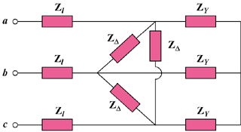

Figure 12.48
For Prob. 12.43.

